Dear Families,

I would like to extend a very warm welcome to all our new pupils and families who have recently joined our school community. I truly hope you have been made to feel welcome and are settling in well!

🚧 Update on School Entrance Fencing

I feel I must address the ongoing presence of the Heras fencing across our main entrance. I apologise for how unsightly this is.

As many of you will know, a car accident just before the half-term break caused significant damage to our external fencing. Thankfully, no one was seriously hurt.

We are actively liaising with our insurers, Hampshire County Council, and third-party insurers to coordinate the necessary repairs. Please be aware that, due to the complexity of these arrangements, the repairs could take some time to complete. We appreciate your patience and understanding in the meantime.

🌸 Reflecting on Remembrance

The theme of remembrance has been central to our school worship this week.

On Tuesday, we explored the different types of poppies that can be worn as symbols of remembrance:

● Red Poppy: The traditional symbol commemorating fallen soldiers.

● White Poppy: A symbol of peace and remembrance for all victims of war.

● Purple Poppy: A tribute honouring the animal victims of conflict.

We reflected deeply on the impact of war in the past and paused to remember those around the world who are still impacted by conflict today

Have a great weekend!
Ian Hickman
Executive Headteacher
Safeguarding
Children being bullied online, particularly in games and via messaging apps, remains one of the top concerns of many parents and their children. Internet Matters have a range of guides and articles to support parents and carers which are listed below:

● Talking to children and conversation tips for ages 6-10, 11-13, 14-17 and vulnerable children https://www.internetmatters.org/issues/cyberbullying/cyberbullying-conversation-starter-guide/

● What is cyberbullying and what are the signs
https://www.internetmatters.org/issues/cyberbullying/learn-about-it/

● Helpful ways to prevent cyberbullying
https://www.internetmatters.org/issues/cyberbullying/protect-your-child/

● How to deal with cyberbullying
https://www.internetmatters.org/issues/cyberbullying/protect-your-child/

● Parents experiences of cyberbullying
https://www.internetmatters.org/issues/cyberbullying/stories/

● Useful resources
https://www.internetmatters.org/issues/cyberbullying/resources/


School Christian Value

This half-term our spotlight is on the Christian value of Trust. Our daily act of worship is based on a theme linked to trust.

“Trust in the LORD with all your heart and lean not on your own understanding; in all your ways submit to him, and he will make your paths straight.” Proverbs 3:5-6

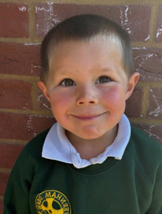
Kindness Award

This week’s Kindness Award goes to Ruben for being kind to both children and adults and for always being considerate of others. Well done, Ruben!

Robins Class
This term, Robins Class are exploring the theme of poppies as part of their learning. In recognition of Remembrance Day, the children thoughtfully shared stories and memories about family members who have served in the military. It was a meaningful opportunity for the class to reflect on the importance of remembrance and to honour the contributions of those who have served.

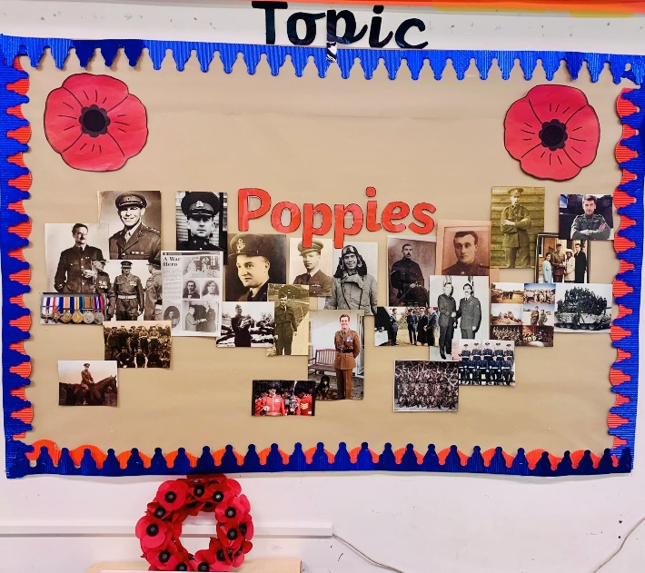

School Uniform Update
Please be advised that school uniform is now available to purchase locally through Happy Fish. Families can now order items directly using the following link:
https://www.happyfish.co.uk/vernham-dean-gillums.

Wraparound Care Update
We would like to keep families informed about the progress of our new wraparound care provision. Our provider is currently awaiting final official paperwork to ensure everything is in place before opening. We expect to have another update soon and will share details with you as soon as they are available. Thank you for your continued patience.

Christmas Crafts Afternoon
We are excited to invite children who will be starting school in September 2026 to a Christmas Crafts Afternoon on Thursday 4th December! It will be a fun and festive opportunity for the children to get creative and make some special holiday-themed crafts to take home. Please see the image below for full details.

If you would like any leaflets to share with friends or family, Miss Pauk in the school office will be happy to provide them. Thank you for helping us spread the festive cheer!

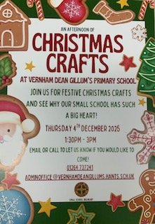

REMINDERS
Rucksacks
Rucksacks should be only used for school trips etc.
Book bags are perfect for bringing into school all the children need eg book, reading record, homework and any letters that go home.

Snacks
Break time snacks should be fruit, vegetables or cheese only please

Parking
When dropping off and picking up your child from school, please refrain from parking in School Close. This is a residential area and should not be used for parking. Please use the Burydeane car park.
DIARY

November
14th – Children in Need
20th – Whole School Tree Planting at Bury Hill
28th – Yr 5 & 6 assisting the Foodbank at Tesco Express Andover (09:30am – 10:30am)

December
4th – Christmas Crafts Open Event
11th – Christingle (2:00pm)
11th – Christmas Jumper Day
11th – Whole School Christmas Dinner at Village Hall
16th – Nativity Play at Village Hall (4:15pm)
18th – Robin Hood & Maid Marion Panto at Newbury Corn Exchange
18th – Carol Service at the Church (2:30pm)
19th – Class Christmas Parties
19th – Break up for Christmas Holidays

INSET DAYS 2026
Monday 23rd February
Friday 3rd July

